1.Write a C++ program to print the name of students by creating a student class. If number and name is passed while creating object of a student class,then the name should be unknown otherwise the name should be equal to screen value while creating the object of the student class.

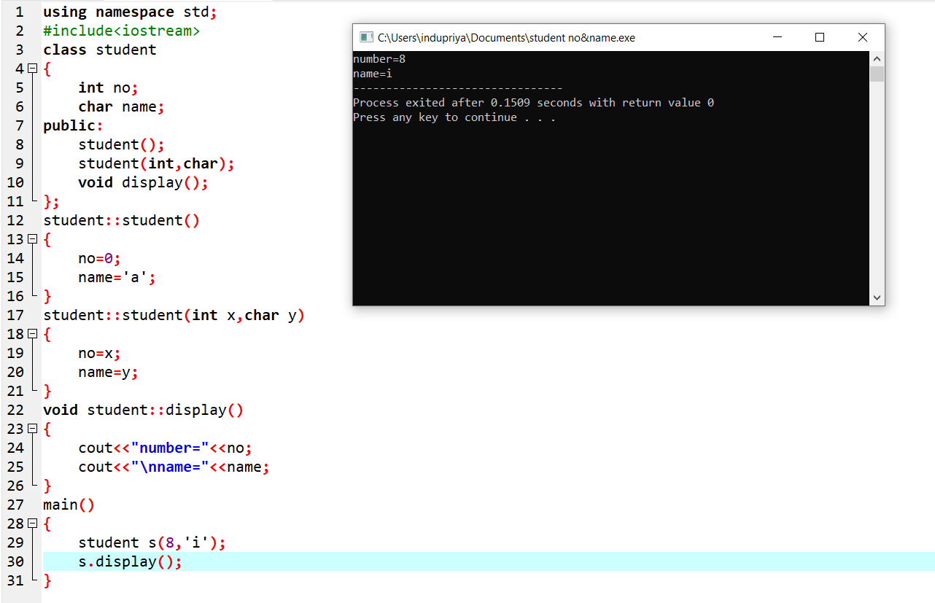

2.Create a class name rectangle with the datamembers length and breadth and a function to calculate the area of rectangle this class contains three constructor.(1)Having no parameters(2) Having two parameters(3) Having only one parameter.

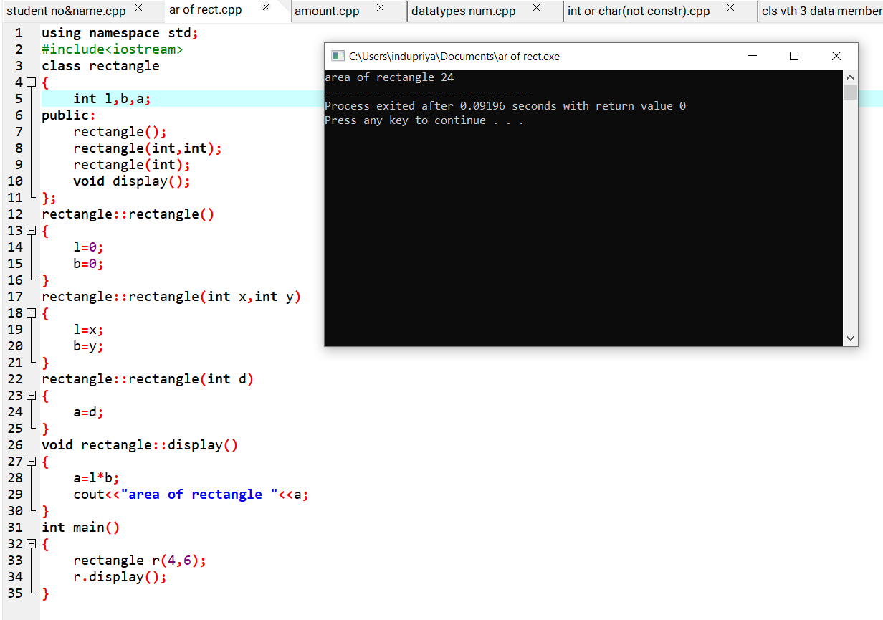

3.Create a class had amount data member is amount with initial value 50.Now make two constructor with their class that is

(1)No parameters i.e no amount is added

(2)Having parameters i.e which is amount will be added into your account

(3)Create an object for had amount class and display the final amount

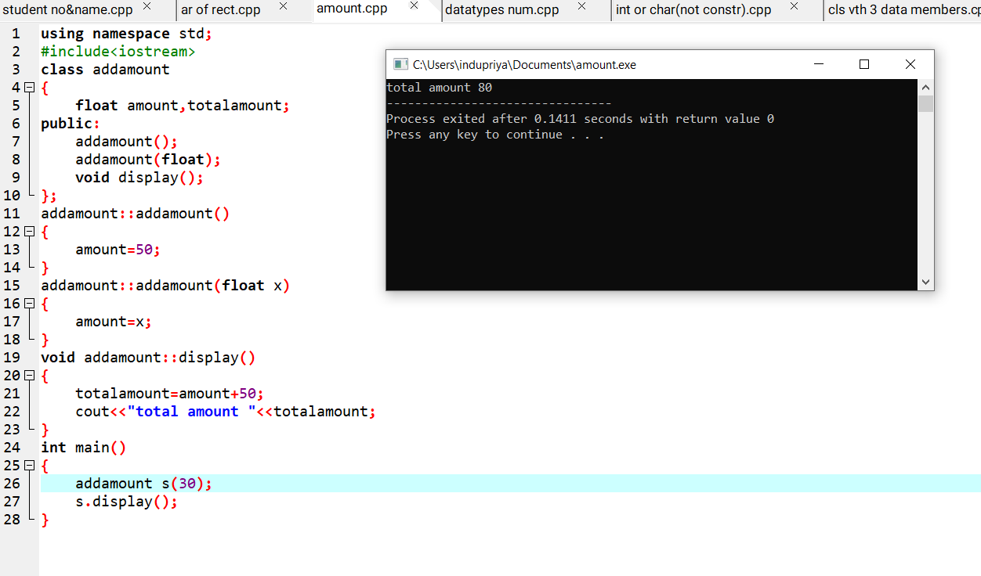

4.Create a class number to print various numbers of different datatypes by creating different functions to the same name print n having a parameter for each datatype.

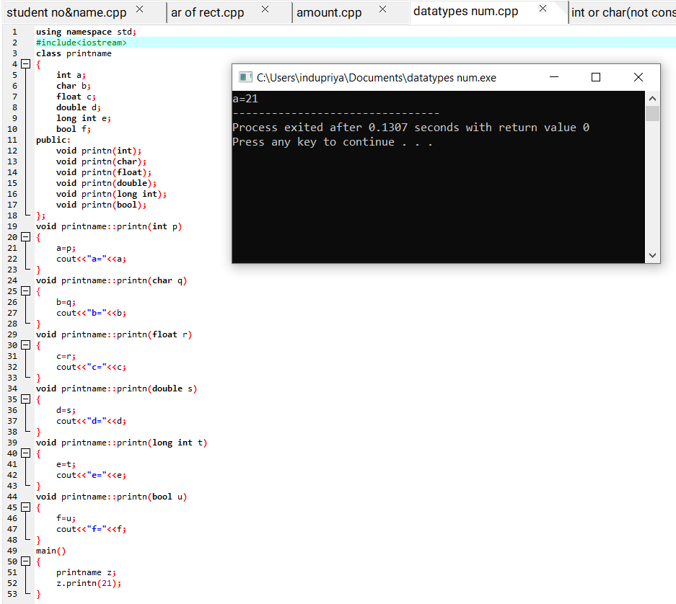

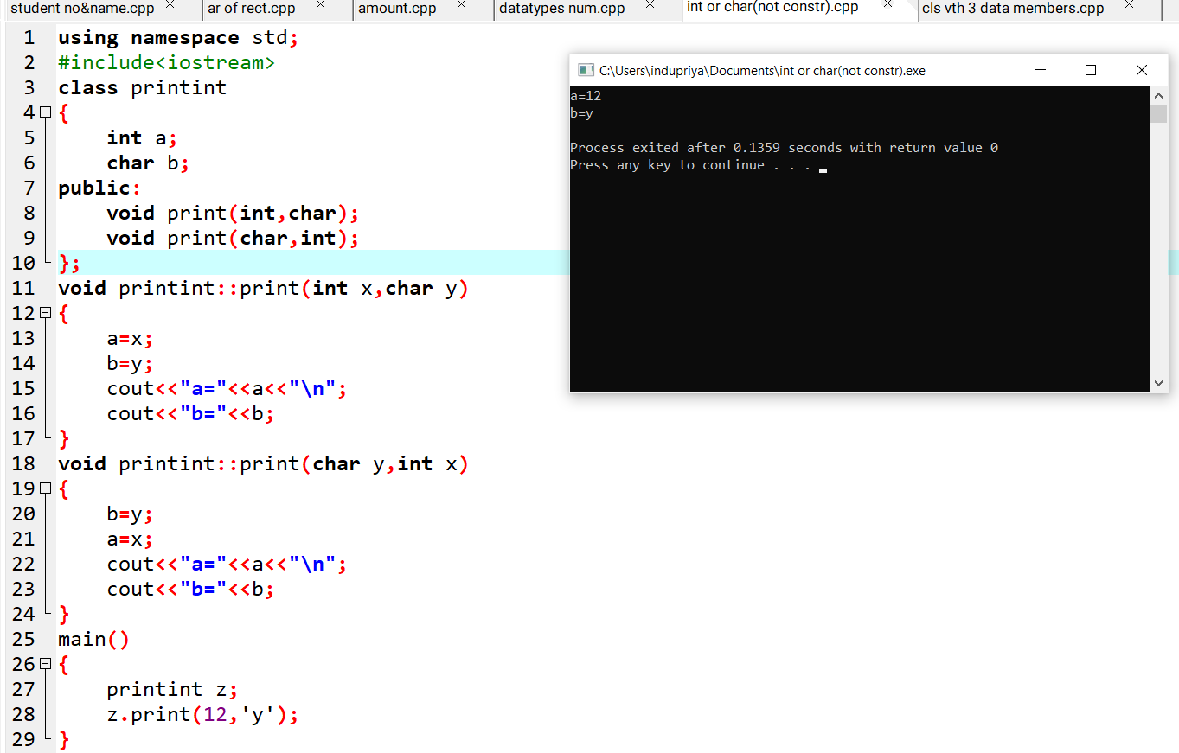5.Create a class to print an integer and character using truth functions having the same name but different sequences of integer and character parameter.

6.Create a class student with three datamembers which are name ,number and address. The constructor of the class assigned default values named as unknown, number as 0,address as not available. It has two functions with same name set info. The first function is two parameters : name and age. And second one is three parameter :name,age and address respectively.Print this details of 10 students.

